**Luke Pepin - CSE3300/CSE5299: Computer Networking**

# Homework 2

Due Date: 9/24, 2024, Tuesday. Submission through HuskyCT.

Full score: 100 for CSE3300 students; 120 for CSE5299 students (will be normalized to 100 when entering the grade in HuskyCT).

1. **Packet delays (30 points).** Consider the queuing delay in a router buffer (preceding an outbound link). Let *I* denote traffic intensity; that is *I* = *La/R*, where *L* is packet length, *a* is the arrival rate and *R* is the transmission rate of the router. Suppose that the queuing delay takes the form of . Suppose *L* = 1500 bytes and *R* = 100 Mbps. Assume the processing delay at the router (i.e., nodal processing delay) is negligible.
   1. (10 points). Suppose *I* = 0. What is the transmission delay at the router? What is the queuing delay at the router? What is the total delay at the router?

If I the traffic intensity = 0:

Transmission delay = L (in bits)/R(in bits)=(1500*8)/(100*10^6)=0.00012s= 0.12ms

Queuing delay = I/(1-I) * L/R = 0 * L/R = 0

Total delay = Transmission + Queuing Delay = 0.12ms

* 1. (20 points). Now let us consider several other cases of *I* values. What is the total delay at the router when *I* = 0*,*0*.*1*,*0*.*2*,*0*.*3*,...,*0*.*9, and 0.99, respectively? Plot the total delay as a function of *I* (Hint: your plot has *I* as the *X* axis and total delay as the *Y* axis, where *I* = 0*,*0*.*1*,*0*.*2*,...,*0*.*9*,*0*.*99). Feel free to use any graphic tool to make the plot.

1. **Packet-switched network: message segmentation (40 points).** Consider sending a large file of *F* bits from Host *A* to Host *B*. There are three links (and two routers) between *A* and *B*. Assume no queuing delay at the routers. Host *A* segments the file into packets of *S* bits each and adds 40 bits of header to each packet. Each link has a transmission rate of *R* Kbps. Suppose *F* = 80*,*000 bits, *R* = 1 Mbps. What is the delay of moving the file from *A* to *B* when (1) *S* = 1000 bytes? (2) *S* = 100 bytes? (We’ll ignore processing delay and propagation delay for this problem). Show intermediate steps.

File Size = F = 80,000 bits

Transmission Rate = R = 1 Mbps = 1,000,000 bps

# of Links = 3

Header size per packet = 40 bits

1. S to bits = 1000 bytes = 8000 bits

Total size per packet (Packet size + header) = 8000 + 40 = 8040

Number of packets (File Size / Packet size) = 80,000 / 8000 = 10

Transmission delay 1 packet (Size per Packet / Transmission Rate) = 8040/1,000,000 = 0.00804 = 8.04 ms

Total Transmission delay (Number of packets * Transmission Delay 1 packet * # of links) = 10*0.00804*3 = 0.2412s = 241.2 ms

1. S to bits = 100 bytes = 800 bits

Total size per packet (Packet size + header) = 800 + 40 = 840

Number of packets (File Size / Packet size) = 80,000 / 800 = 100

Transmission delay 1 packet (Size per Packet / Transmission Rate) = 840/1,000,000 = 0.00084 = 0.84 ms

Total Transmission delay (Number of packets * Transmission Delay 1 packet * # of links) = 100*0.00084*3 = 0.252s = 252ms

1. **Packet losses (10 points).** Suppose two end hosts, *A* and *B*, are connected by 10 links, each with packet loss probability *p* (0 *< p <* 1), and the loss probabilities for these links are independent. What is the probability that a packet sent form *A* is received successfully at the receiver *B*?

Packet loss probability = p

The loss probability is independent

Therefore:

Probability successful transmission = (1 - p)^10

1. **Wireshark labs (20 points).** Work on Wireshark “Intro” and “HTTP” lab (posted in HuskyCT). You do not need to turn in anything for the “Intro” lab; you just need to read the lab document and go through the steps to get comfortable with using Wireshark. For the “HTTP” lab, please submit your answers to questions 1-7 (on “The Basic HTTP GET/response interaction”).

Full image of my wireshark working: 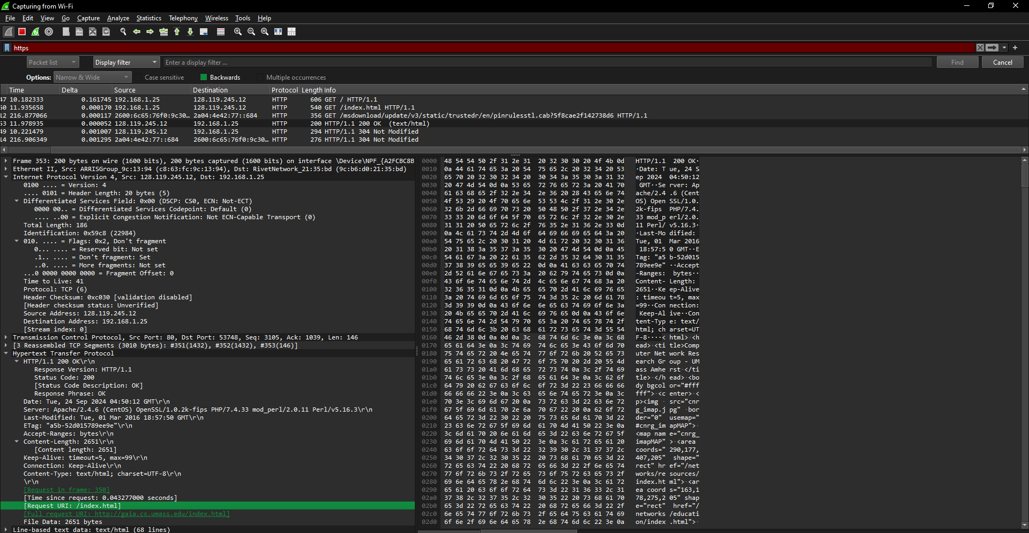

1. Is your browser running HTTP version 1.0 or 1.1? What version of HTTP is the server running? Both Browser and Server use HTTP version 1.1

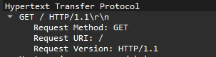

2. What languages (if any) does your browser indicate that it can accept to the server? 

3. What is the IP address of your computer? Of the gaia.cs.umass.edu server?



4. What is the status code returned from the server to your browser?

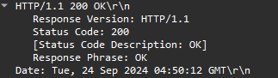

5. When was the HTML file that you are retrieving last modified at the server?



6. How many bytes of content are being returned to your browser?



7. By inspecting the raw data in the packet content window, do you see any headers within the data that are not displayed in the packet-listing window? If so, name one.

The text data

